Web technology and Mobile Application
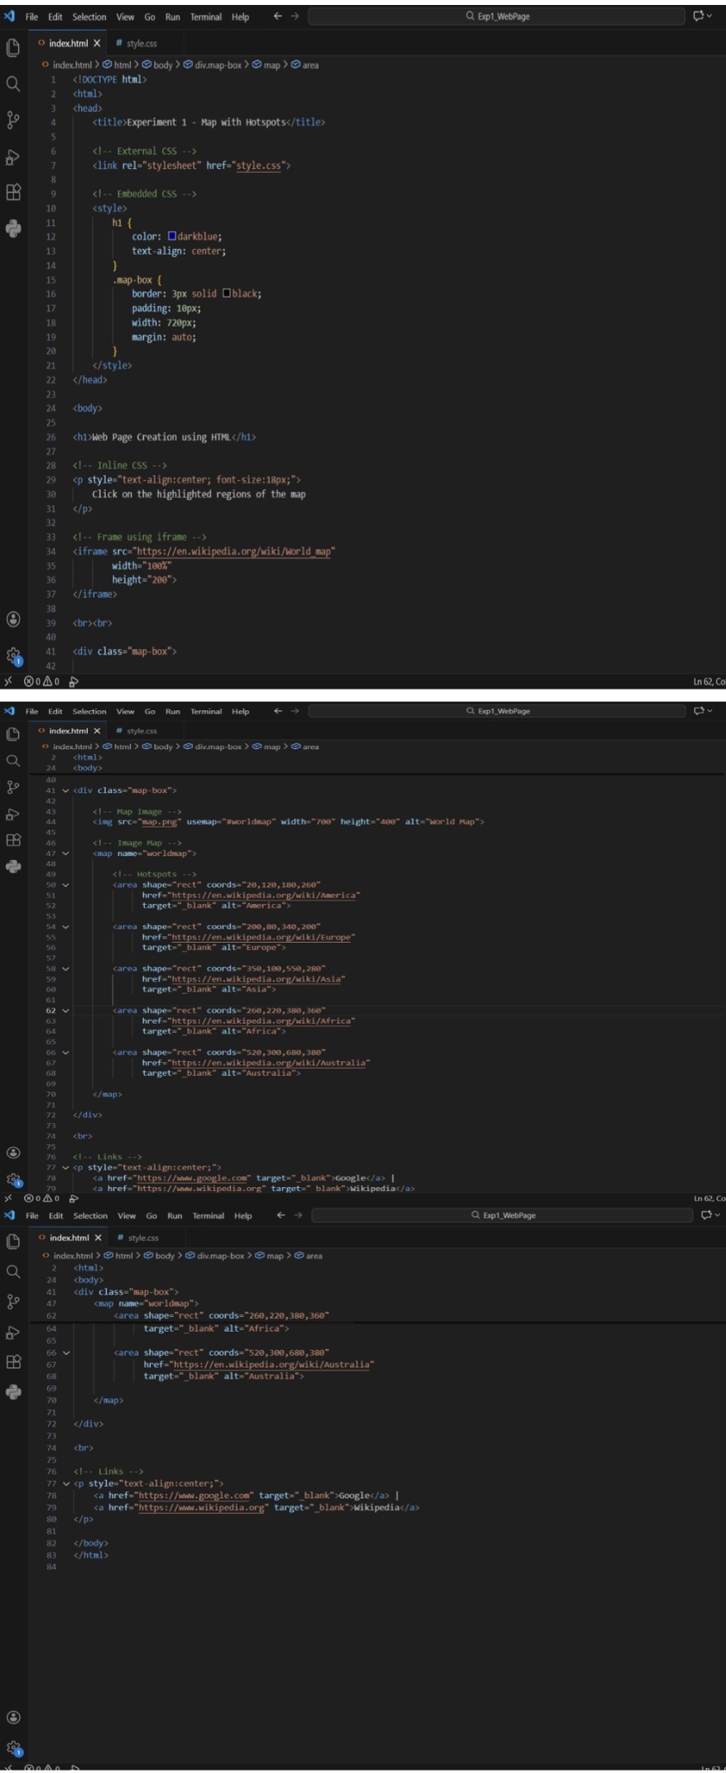
Exp 1 - Abhinaya RD (241801004)
HTML code:

CSS code:
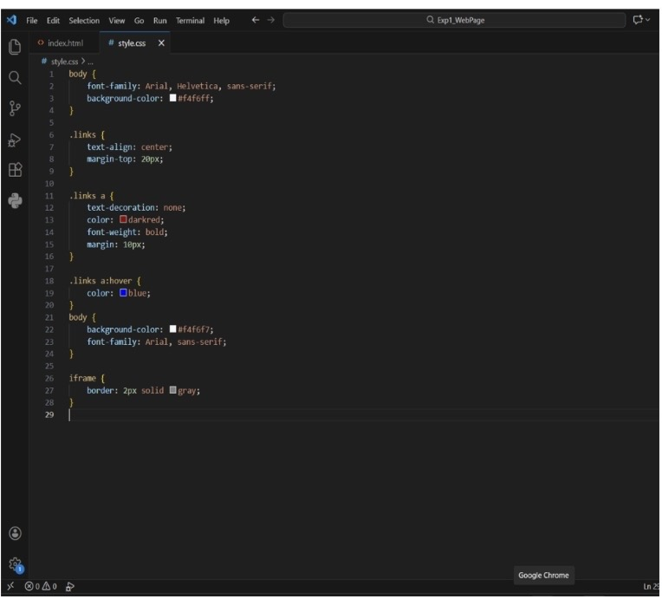

OUTPUT:
